








Welcome to

2026-2027



Dear families,
A very warm welcome to Kedington Primary School. We are delighted that your child will be joining our school community and look forward to getting to know your family over the coming years.
Starting school, or joining a new school, is an exciting milestone and we are committed to making the transition as smooth and positive as possible. We hope this booklet answers many of your questions and provides useful information about life at Kedington. If there is anything else you would like to know, please do not hesitate to contact us. We are always happy to help.
At Kedington, we are proud to combine high academic expectations with a warm, nurturing environment where every child is known, valued, and supported. In our most recent Ofsted inspection (July 2024), inspectors recognised the exceptional quality of education and care we provide, noting that "Pupils delight in coming to school", that "Pupils' behaviour is exemplary", and that the evidence suggested the school may be judged Outstanding if a full graded inspection were carried out.
We believe children achieve their very best when schools and families work closely together. Our aim is to provide a happy, safe, and inspiring learning environment in which every child can thrive, develop confidence and resilience, and foster a lifelong love of learning.
Throughout the year, we welcome families into school for a wide range of events, including parent consultations, productions, celebration assemblies, curriculum events, parent lunches, sports activities, and opportunities to share and celebrate children's learning. One of our favourite weekly traditions is our Kedington Champion Assembly, where we come together to celebrate pupils' achievements and successes.

Strong relationships are at the heart of our school. We are committed to communicating openly and honestly with families and value the trust that parents place in us. If you ever have a concern, question, or worry, however small it may seem, please do get in touch. We believe that by working together we can provide the very best experience for every child.
We look forward to welcoming you and your child into the Kedington family.


Vicky Doherty
Headteacher

Our Aims, Values and Curriculum

Appreciating what we have... aspiring to greater things.
This motto lies at the heart of life at Kedington Primary School and reflects the values that guide our children, staff, and wider community.
We encourage our children to appreciate who they are, what they have achieved, and the opportunities available to them. We want them to recognise their strengths, value each other, and develop gratitude for the people and world around them.
At the same time, we inspire children to aspire to greater things. We encourage them to be ambitious for themselves, curious about the wider world, and determined to become the very best version of themselves. Whether in their learning, friendships, talents, or personal achievements, we help children develop the confidence and resilience to embrace new challenges and opportunities.
These values are woven through every aspect of school life. We celebrate success, effort, kindness, and perseverance, while continually encouraging children to learn more, achieve more, and grow as individuals.

Our Curriculum
We believe that education should shape not only what children know, but also the people they become and the skills they develop for the future. We describe this through our Head, Heart and Hands approach:
- Head – developing knowledge, understanding, and a love of learning.
- Heart – nurturing character, values, wellbeing, and positive relationships.
- Hands – building practical skills, creativity, independence, and resilience.
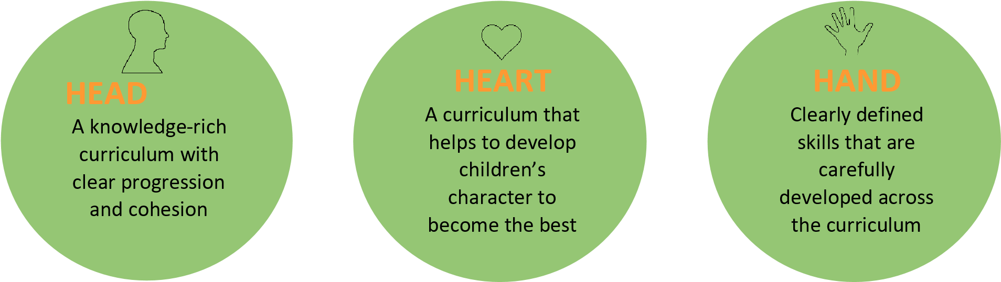
In Reception, children follow the Early Years Foundation Stage curriculum through a balance of carefully planned teaching, play-based learning, and exploration. A strong emphasis on phonics, language development, and early mathematical understanding ensures children make an excellent start to their school journey.
From Year 1 onwards, subjects are taught discretely through our ambitious curriculum. We use the Curriculum with Unity Schools Partnership (CUSP) for most subjects, ensuring that learning is carefully sequenced and builds knowledge, vocabulary, and understanding over time. Our curriculum is informed by the latest educational research and helps children develop both the knowledge and skills they need to thrive in an ever-changing world.
Parents have the right to withdraw their child from Religious Education lessons. If you would like to discuss this, please contact the school office.
PSHE and Relationships, Sex and Health Education (RSHE)
At Kedington Primary School, we believe that children's personal development is just as important as their academic achievement. Through our Personal, Social, Health and Economic (PSHE) curriculum, children develop the knowledge, skills, and understanding they need to stay healthy, safe, and happy, both now and in the future.
Our PSHE and Relationships, Sex and Health Education (RSHE) curriculum helps children to develop positive relationships, understand and manage their emotions, learn about physical and mental wellbeing, stay safe online, celebrate diversity, and become responsible members of their communities. Lessons are carefully planned and taught in an age-appropriate and sensitive way, building children's knowledge progressively as they move through the school.
We recognise that parents are the primary educators of their children in matters relating to relationships and health, and we value the important role families play in supporting this learning. Parents have the right to withdraw their child from the sex education elements of RSE that are taught beyond the National Curriculum for Science. However, there is no right to withdraw from the statutory Relationships Education curriculum or from the Science curriculum, including the aspects of human development that form part of it.
Further information about what is taught in each year group can be found in our RSHE Policy, which is available on the school website. If you have any questions about the curriculum, we would be happy to discuss them with you.
Our Values
A key part of our focus on developing the heart is our commitment to our six core values. These values help to shape the way we learn, behave, and interact with one another, and are at the centre of our school culture.
Each half term, we focus on one value through assemblies, classroom learning, discussions, and everyday experiences. By exploring each value in depth, children develop a shared understanding of what it means and how it can be demonstrated both in school and beyond.
Our values encourage children to become kind, respectful, resilient, and responsible individuals who make a positive contribution to their communities.
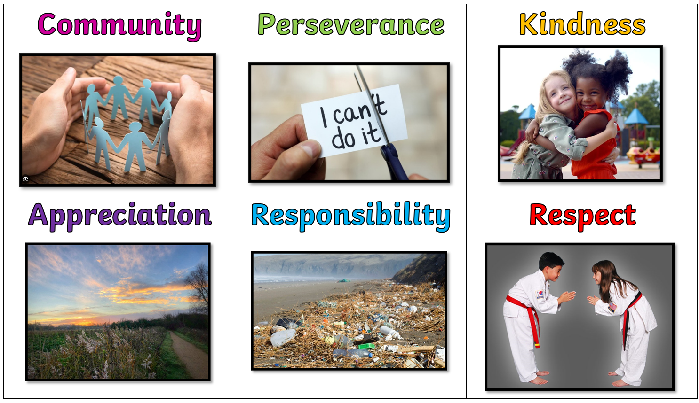
This consistent focus helps create the caring, inclusive, and respectful environment that visitors so often notice when they walk through our doors.
Zones of Regulation
Another important part of our Heart curriculum is helping children to understand their emotions and develop the skills to manage them effectively.
At Kedington, we use Zones of Regulation to teach children that all emotions are normal and that everyone experiences a range of feelings throughout the day. Children learn to recognise different emotional states, understand how these might affect their behaviour and learning, and develop a range of strategies to help them regulate their emotions when they become overwhelming.
Through class discussions, activities, and everyday practice, children build a personalised "toolkit" of strategies that they can use to help themselves feel calm, focused, and ready to learn.
This approach supports children's emotional wellbeing, resilience, and independence, while helping to create the calm, caring, and supportive environment that is such an important part of life at Kedington Primary School.
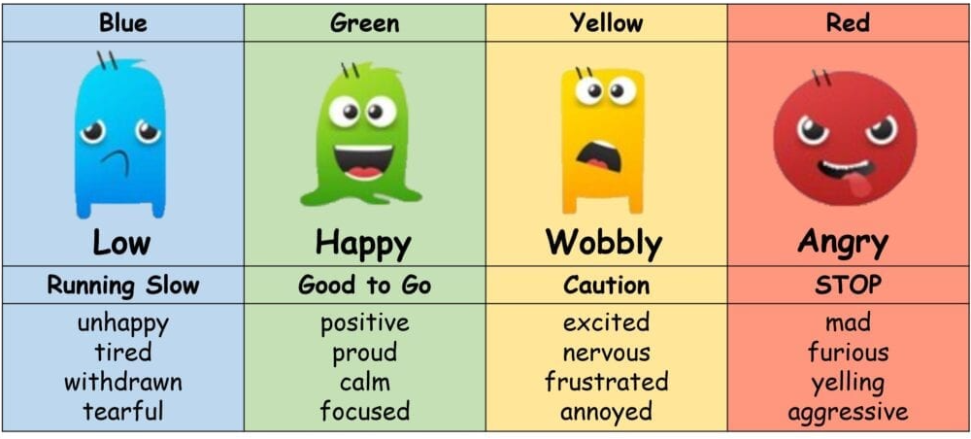

Role Models and The Kedington Way
At Kedington Primary School, we believe that kindness, good manners, and consideration for others are just as important as academic success. We want our children to develop into thoughtful, respectful young people who make a positive difference to those around them.
To support this, we promote The Kedington Way: a set of 15 everyday behaviours that help children understand what it means to be a valued member of our school community. These include simple but important actions such as saying "please" and "thank you", opening doors for others, taking pride in our environment, and showing respect and care towards everyone.
Children are encouraged to demonstrate these behaviours consistently throughout their time at school. Each term, teachers nominate a small number of pupils who exemplify The Kedington Way in all that they do. These children are awarded the prestigious status of Kedington Role Model, recognising them as outstanding ambassadors for our school values.
By celebrating these positive behaviours, we help children understand that character, kindness, and integrity matter, and that the small things we do every day can have a big impact on others.
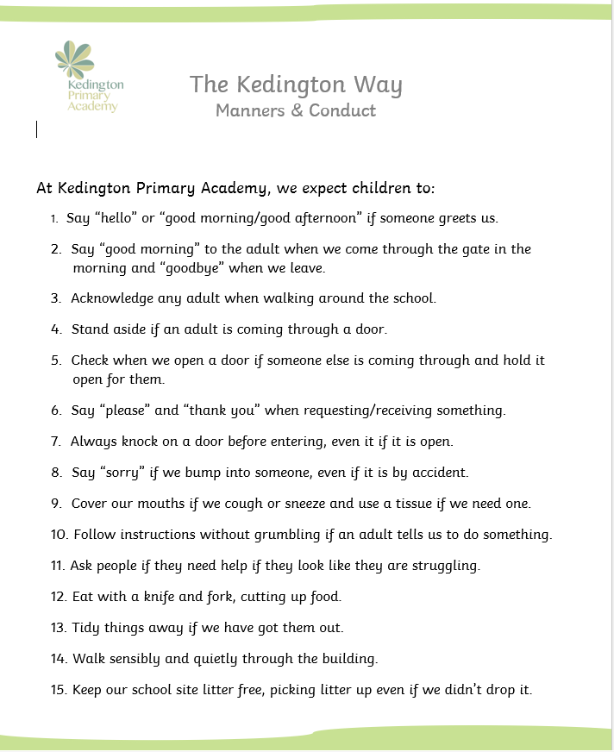

Unity Schools Partnership
Kedington Primary School is proud to be part of Unity Schools Partnership, a family of schools united by a shared ambition to transform lives through education.
The trust includes around 30 primary, secondary, special, and middle schools across Suffolk and neighbouring areas, providing a strong network of support, expertise, and collaboration. While every school retains its own unique identity and community, we all share a commitment to ensuring that every child is known, valued, and able to flourish.
Being part of Unity Schools Partnership brings many benefits to our children and families. Our staff have access to high-quality professional development, the latest educational research, and opportunities to work alongside expert colleagues across the trust. This helps us continually refine our practice and ensure that children benefit from innovative, evidence-informed approaches to teaching and learning.
The trust also provides a range of central services, including finance, HR, estates, IT, and governance support. This allows school leaders and staff to focus on what matters most: providing an exceptional education and the best possible experience for our children.
Most importantly, being part of Unity Schools Partnership means that we are able to combine the warmth, community spirit, and personal approach of a village primary school with the opportunities, expertise, and resources of a larger organisation.
For more information about Unity Schools Partnership, please visit www.unitysp.co.uk.
Staff and Governors
Teaching Staff:
 | Mrs V Doherty  Mrs L Wreathall  Mrs C Reeder  Mrs L Hunter  Mrs D Dearman  Ms B Mackenzie  Mrs K Beard  Mrs C Kimber  Ms S Caves  Miss C Morey  Mrs C Kimber  Mr C Long  Mrs I Weaver | Headteacher  SENCO/ Interim Deputy Head, Y6 teacher  Reception teacher  Reception teacher  Y1 teacher  Y1 teacher  Y2 teacher  Y2 teacher  Y3 teacher  Y4 teacher  Y4 teacher  Y5 teacher  Y6 teacher
Support Staff: | Mrs S Duers  Mrs K Foyster  Ms A Carter  VACANCY  Rachel Gould  Danielle Thompson  Harriet Solt  Sarah Hewitt (pt)  Nicole Thompson  Ronnie Hallinan  Sue Norden  Suzanne Bradnan  Beth Mills  Sarah Lawlor  Justine Hart  Rosie Fisher  Nichola Runswick | Office manager  Administrative assistant  Administrative assistant  Learning Support Assistant Y6  Learning Support Assistant Y5 (pt)  Learning Support Assistant Y4  Learning Support Assistant Y4 (apprentice)  Learning Support Assistant Y3 (Fridays)  Learning Support Assistant Y3  Learning Support Assistant (pt) Y3  Learning Support Assistant Y2  Learning Support Assistant Y1  Learning Support Assistant Y1  Learning Support Assistant YR  Learning Support Assistant YR  Learning Support Assistant YR  ELSA/ Forest School Leader
Chair of Governors | Mrs K Umande

Class Organisation
The school is organised in seven classes as follows:
Age | Year Group | Class
4-5 | Reception | China
5-6 | Year 1 | Brazil
6-7 | Year 2 | Kenya
7-8 | Year 3 | Italy
8-9 | Year 4 | Egypt
9-10 | Year 5 | Antarctica
10-11 | Year 6 | Jamaica

School Sessions
The school week runs from Monday to Friday.
Our school gate opens at 8.35am, and children should arrive by 8.40am ready to start their day. A member of the Senior Leadership Team welcomes children and families at the gate each morning and is available to speak with parents if needed.
As children grow in confidence and independence, we encourage pupils from Year 2 onwards to say goodbye at the gate and make their way to their classroom independently, where they will be greeted by their teacher. Younger children are welcome to be accompanied to their classroom door by their parent or carer.
As children move through the school, we encourage increasing levels of independence. During the summer term of Year 5 and throughout Year 6, children may travel to and from school independently with parental permission, helping them prepare for the transition to secondary school.
The school day ends at 3.15pm. Children are collected from the external door of their classroom, providing a valuable opportunity for informal communication between families and staff when needed.
Our approach to the start and end of the day reflects our commitment to building children's independence while maintaining the strong relationships between home and school that are so important to us. We believe that a warm welcome at the beginning of the day and positive goodbyes at the end help children feel safe, settled, and ready to learn.

Total Time in School
The school is open for 32 hours and 55 minutes per week, in line with current government expectations for primary schools.

Attendance
We know that children achieve their best when they attend school regularly. Good attendance helps children build strong friendships, feel part of the school community, and make the most of all the learning and experiences that school has to offer.
We understand that there are sometimes circumstances which make attending school difficult. If your child is experiencing challenges that are affecting their attendance, whether these are medical, emotional, social, or family-related, please talk to us. We are committed to working in partnership with families to identify any barriers and provide support wherever possible. We also offer a Calm Start provision in our Rainbow Room for children who may find coming into school difficult at times. This provides a supportive and nurturing start to the day, helping children feel settled, ready to learn, and successful in attending school regularly.
The Government expects holidays to be taken during school holiday periods. Requests for leave during term time can only be authorised in exceptional circumstances. Unauthorised holidays of three days or more may result in a Fixed Penalty Notice being issued in line with current regulations.
The morning register is taken promptly at 8.40am and closes at 8.55am. Children who arrive after registration has started but before 8.55am will be marked as late. Arrivals after 8.55am are recorded as an unauthorised absence for that session.
Further information can be found in our Attendance Policy, available on the school website.
Parents can monitor their child's attendance, punctuality, and absence record through the Arbor Parent App, our school management system. Arbor also provides access to a range of other useful information and communications, helping families stay informed and engaged with school life.

School Uniform
We believe that our school uniform plays an important role in creating a sense of belonging and pride in our school community. It helps to promote equality, supports our positive school culture, and ensures that children come to school ready to learn.
Branded uniform items featuring the school logo are available from our approved suppliers (Kiwwi Clothing ; My Uniform and Corporate Tiger) however, these are not compulsory. Many families choose unbranded items that meet our uniform requirements, and these are equally acceptable. We are committed to keeping uniform affordable and accessible for all families.
We also maintain a large stock of good-quality, donated second-hand uniform, which is available free of charge. Families are welcome to contact the school office if they would like to make use of this resource.
Children wear their PE kit to school on their designated PE days, allowing them to maximise learning time and be ready for physical activity throughout the day.
Please see the school's Uniform Policy on our website for full details of uniform requirements.
All Children
White shirt
Long or short sleeved
Tie
elasticated or traditional
(Children in Reception can wear a polo shirt and no tie all year)
Grey skirt/pinafore dress/ shorts/trousers (not jogging bottoms)
Skirts and shorts should not be too short and trousers should be full length
Green V-necked jumper or cardigan
Plain white, grey, white or black socks or tights
Flat, black shoes (not trainers, boots or sandals)
These should be appropriate for school. Your child should wear shoes which he or she can manage to do up independently Please do not send your child to school in shoes which prevent them from running in the playground. Open toed shoes are not allowed.
Optional Summer Uniform
(from Easter to October Half Term)
Green and white checked dress
White polo shirt (no tie)
PE Kit
(To be worn to school on PE days)
Plain white t-shirt
Black shorts/ jogging bottoms/ leggings
Dark green hoodie or sweatshirt
Trainers

School Lunches
Children can either have a school meal or bring a packed lunch from home. Our school meals are provided by Caterlink and are freshly prepared on site each day. The menus are carefully planned to be healthy, balanced, and appealing to children, and our catering team works hard to ensure that mealtimes are a positive experience.
There is a choice of hot and cold options each day, including a vegetarian option and jacket potatoes. Parents are encouraged to select their child's meal choice in advance using the Arbor Parent App (see Communication), although children can also make their choice in class each morning. Current menus are sent home regularly and are available on the school website.
School meals are free for all children in Reception, Year 1, and Year 2 through the Universal Infant Free School Meals scheme. Children from eligible low-income families in other year groups may also qualify for free school meals (see Pupil Premium). The current cost of a school meal for children in Year 3 and above is £2.90 per day, payable through Arbor.
Children may bring a healthy packed lunch from home if preferred. Water is available throughout the day, although children are welcome to bring a drink to have with their lunch (please no fizzy drinks). As a school, we encourage healthy choices and ask that packed lunches do not contain sweets. Please note that Kedington Primary School is a nut-free school, and we ask families not to send any products containing nuts.
All children should bring a named water bottle to school each day. Water bottles are kept in classrooms and are accessible throughout the day and at break times.

Snacks
Children in Reception, Year 1, and Year 2 receive a free piece of fruit or vegetable each day as part of the government's school fruit and vegetable scheme.
Children in Key Stage 2 are welcome to bring a healthy snack from home for break time. Suitable snacks include fruit, vegetables, cheese, crackers, or similar healthy options. To promote healthy eating, crisps, sweets, chocolate, and other confectionery should not be brought into school as snacks.
We encourage all children to develop healthy eating habits and make positive choices that support their wellbeing and readiness to learn.

Pupil Premium and Other Additional Funding
The Government provides schools with additional funding to support the achievement and wellbeing of children who may face particular barriers to learning.

Pupil Premium
Children may be eligible for Pupil Premium funding if they are entitled to Free School Meals (FSM), or have been eligible for Free School Meals at any point in the last six years. For primary-aged pupils, this funding is currently worth £1,515 per eligible child per year to the school.
This additional funding enables us to provide a range of support and opportunities, including our Pupil Premium Package, which may include assistance with school uniform, music tuition, educational visits, enrichment activities, and other forms of support designed to help children thrive both academically and socially.
Even if your child receives Universal Infant Free School Meals in Reception, Year 1, or Year 2, it is still extremely important to apply if you think you may be eligible. Registering can unlock significant additional funding for the school and support for your child. If you think you may qualify, please speak to the school office in confidence or visit the Suffolk County Council website for further information.

Children in Care and Previously Looked-After Children
Additional funding is also available for children who are currently in the care of a local authority and for children who were previously in care but are now subject to an Adoption Order, Special Guardianship Order (SGO), Child Arrangements Order, or equivalent arrangements.
If this applies to your child and the school is not already aware, please let us know so that we can ensure the appropriate support and funding are in place.

Service Pupil Premium
Children with a parent serving in the regular armed forces, children whose parent has died whilst serving in the armed forces, or children who have been recorded as a service child in recent years may be eligible for Service Pupil Premium funding. This funding helps schools provide pastoral and emotional support to children from service families.
If your child has a parent currently serving, or has previously served, in the armed forces, please inform the school office so that we can check whether they are eligible.
We are committed to ensuring that all children, regardless of their circumstances, have access to the support, opportunities, and experiences they need to flourish and reach their full potential.

Homework
At Kedington Primary School, our approach to homework is based on research about what best supports children's learning. We focus on activities that help children practise, consolidate, and remember the knowledge and skills they have learned in school.

Reading
Reading is the most important part of homework. Research consistently shows a strong link between reading for pleasure and academic success, and regular reading at home plays a vital role in helping children become confident, fluent readers.
From Reception onwards, children will bring books home to share with their families. As they begin learning phonics, they will also be given books that closely match their reading ability so that they can practise and apply their developing skills. Reading with an adult at home makes a significant difference to children's progress, confidence, and enjoyment of reading.
We ask all children to read at home at least four times each week throughout their time at Kedington.

Other Homework
In addition to reading, children may be given activities that reinforce key learning, such as practising spellings, learning important vocabulary, playing mathematical games, or revisiting concepts taught in class.
Homework is set through our online learning platform, Showbie, and families will be provided with login details. Showbie is also used to share curriculum information, including our half-termly Knowledge Organisers, which outline the key knowledge and vocabulary children will be learning in each subject.
Children may be asked to discuss these with an adult at home and answer simple questions to help strengthen their understanding and support long-term memory.
As children move through the school, the amount of homework gradually increases in preparation for the expectations of secondary school, while remaining manageable and purposeful.
Further information can be found in our Homework Policy, available on the school website.

Communication
We believe that strong communication and positive relationships between home and school are essential to ensuring that every child thrives. We aim to be approachable, responsive, and open, and we encourage parents to contact us whenever they have a question, concern, or information they would like to share. No concern is ever too small, and we would always rather have a conversation early so that we can work together in partnership.

ClassDojo
Teachers use ClassDojo, a secure communication platform that helps families stay connected with classroom life. Throughout the year, teachers share photographs, updates, celebrations, reminders, and information about what children have been learning. Parents can also use ClassDojo to contact their child's teacher if this is the most convenient way to get in touch.
You will be given instructions on how to join ClassDojo once your child starts school.
Arbor Parent App
All parents will also be asked to download the Arbor Parent App, which is our school management system. Arbor allows you to:
- Complete consent forms and update contact details.
- Book and pay for trips, clubs, and activities.
- Order school meals.
- View your child's attendance record.
- Receive school communications and important updates.
Please note that emails sent from Arbor can occasionally be filtered into junk or spam folders, particularly when you first start receiving communications from the school. We recommend checking these folders regularly and adding Arbor to your safe senders list to ensure you do not miss any important information.
We encourage all families to make full use of Arbor as it is an important part of our communication with parents.
Keeping Families Informed
A monthly newsletter is sent to families via Arbor and shared on ClassDojo. This includes key dates, reminders, celebrations, and information about forthcoming events.
In addition, teachers share a termly class newsletter containing information specific to your child's year group. This includes an overview of what children will be learning during the term, key events and trips, homework expectations, PE days, Forest School sessions (where applicable), and any other practical information that families may need.

Speaking to Staff
Members of the Senior Leadership Team are available on the gate each morning and are always happy to help if needed. Teachers are usually available for brief conversations at the end of the school day and can also be contacted through ClassDojo or via the school office.
While staff aim to respond to messages as promptly as possible, teachers will not usually be able to read messages during teaching time. We also believe in supporting staff wellbeing and therefore do not expect teachers to monitor or respond to messages outside of their working day.
Parents' Evenings and Reports
Formal parent consultation meetings take place twice each year, in the autumn and spring terms, providing an opportunity to discuss your child's progress, achievements, and next steps with their teacher.
Parents also receive:
- A written annual report in the summer term.
- Termly interim reports outlining progress and attainment.
For children with additional needs, we work closely with families and provide opportunities for more regular review meetings to discuss progress, support, and next steps.
We value the trust that families place in us and believe that when schools and parents work together, children receive the very best support to flourish both academically and personally.

Complaints Procedure
We are proud of the strong relationships we build with our families and believe that open, honest communication helps to resolve most concerns quickly and positively. If you have a worry or concern, however small it may seem, we encourage you to contact us as soon as possible so that we can work together to find a solution.
In the first instance, concerns should be discussed with your child's class teacher. If further support is needed, the matter can be referred to the Headteacher, who will work with you to resolve the issue informally and as quickly as possible.
On the rare occasion that a concern cannot be resolved in this way, a formal complaints process is available. Depending on the stage of the process, this may involve representatives from Unity Schools Partnership, including the school's Primary Link Director, in accordance with the Trust's Complaints Policy.
A copy of the Complaints Policy can be found on the Unity Schools Partnership website or obtained from the school office. We welcome feedback from parents and carers and view concerns as an opportunity to strengthen the partnership between home and school and continually improve what we do.

Behaviour and Relationships
We are incredibly proud of the behaviour, attitudes, and conduct of our children. During our most recent Ofsted inspection, inspectors recognised this as a particular strength of the school, describing pupils' behaviour as exemplary and highlighting the culture of respect that flows throughout the school.
At Kedington Primary School, we believe that positive behaviour is built through strong relationships, high expectations, and a sense of belonging. We want all children to feel safe, valued, and supported, and we work hard to create an environment where every child can thrive.
Our approach is underpinned by three simple school rules that all children know and understand:
- Be Kind
- Work Hard
- Be Safe
These rules are reflected in everyday life around the school. Visitors often comment on our children's politeness, good manners, and consideration for others, whether that is holding doors open, helping younger children, greeting adults respectfully, or taking pride in their school environment.
We place a strong emphasis on recognising and celebrating positive behaviour. Staff build warm, trusting relationships with children and use praise, encouragement, and positive recognition to reinforce our expectations. Alongside this, we explicitly teach children the social, emotional, and behavioural skills they need to be successful.
When difficulties arise, we take a supportive and restorative approach. We help children to understand the impact of their actions, reflect on what has happened, and consider what they can do differently in the future. A key part of this process is helping children to repair relationships and put things right where appropriate.
We recognise that behaviour is a form of communication and that some children may need additional support to meet expectations. Where needed, we work closely with families to understand individual needs and put appropriate support in place.
Further information can be found in our Behaviour and Relationships Policy on the school website.

Photography and Filming
We regularly use photographs and videos to celebrate children's achievements, record learning, share experiences with families, and showcase life at Kedington Primary School. Images may be used in a variety of ways, including classroom displays, learning journals, newsletters, ClassDojo, the school website, school publications, and occasionally local media coverage.
When your child starts at school, you will be asked to complete a consent form indicating how their images may be used. We will always respect the choices that families make and ensure that any photographs or videos are used in accordance with the permissions provided.
We would, however, encourage parents to consider giving consent where possible. Photographs and videos are an important way for us to celebrate children's successes, share special moments with families, and help children feel proud of their achievements. Where consent is not given, it can sometimes mean that children cannot be included in class photographs, displays, social media posts, or other celebrations of school life.
If you have any concerns about the use of photographs or videos, please speak to us. We are always happy to discuss individual circumstances and explain the steps we take to ensure images are used safely and appropriately.

Safeguarding
The safety and wellbeing of our children is our highest priority. At Kedington Primary School, we are committed to safeguarding and promoting the welfare of every child and work hard to ensure that all pupils feel safe, supported, listened to, and valued.
Safeguarding is everyone's responsibility. All staff receive regular safeguarding training and understand the important role they play in protecting children and responding to concerns. We teach children how to keep themselves safe, both in the real world and online, and encourage them to speak to a trusted adult if they are worried about anything.
The school works closely in partnership with families to support children in every way possible. While we always seek to build relationships based on trust and openness, parents and carers should be aware that we cannot guarantee confidentiality if information is shared that suggests a child may be at risk of harm. In these circumstances, we have a legal duty to follow safeguarding procedures and may need to share information with other agencies in order to keep children safe.
Our Designated Safeguarding Lead (DSL) is:
- Mrs Vicky Doherty (Headteacher)
Our Deputy Designated Safeguarding Leads are:
- Mrs Laura Wreathall (SENDCo)
- Mrs Karen Beard (Teacher)

Supporting Children and Families
At Kedington, we strongly believe in the importance of early help and early intervention. Sometimes families need a little extra support, and we are committed to working alongside parents to identify needs and access help as early as possible.
Our safeguarding team can offer advice, guidance, and signposting to a range of support services. Where appropriate, we may suggest completing an Early Help Assessment together with the family. Using a Signs of Safety approach, this helps us identify a family's strengths as well as any areas where additional support may be beneficial. It can then help coordinate support from relevant agencies to ensure children and families receive the help they need.
If you feel that your family would benefit from additional support, please speak to Mrs Doherty. We understand that everyone needs help from time to time and will always approach conversations with care, respect, and a commitment to finding the right support.
Parents and carers are asked to familiarise themselves with the school's Safeguarding Policy, which is available on the school website. A paper copy can also be obtained from the school office on request.

Medicines and Medical Needs
At Kedington Primary School, we are committed to supporting children with medical needs so that they can participate fully in school life. Our Meeting Health Needs Policy is available on the school website and provides full details of our procedures.
If your child needs medication during the school day, a member of staff can administer this. To help us manage this safely, we ask that medicines are given at home wherever possible. For example, many antibiotics can be given before school, after school, and in the evening without needing to be administered during the school day.
Any medication that needs to be given at school must:
- Be brought to the school office by an adult.
- Be collected from the office at the end of the day.
- Be accompanied by a completed and signed medication form.
- Be provided in its original packaging with clear dosage instructions.
Medication cannot be administered without written parental consent.

Long-Term Medical Conditions
Where children require ongoing medication or have a medical condition such as asthma, allergies, epilepsy, or diabetes, we work closely with parents to develop an Individual Healthcare Plan. This helps ensure that staff understand your child's needs and know how best to support them.
If you have indicated on your admissions paperwork that your child has a medical condition, a member of staff will contact you to discuss any support that may be required. Parents are responsible for informing the school of any changes to their child's medical needs and for ensuring that medication remains in date and is replaced when necessary.
For the safety of all children, medicines are generally not kept in classrooms or carried by pupils. The exception to this may be emergency medication, such as asthma inhalers which are kept in a portable box in the classroom.

Emergency Medication
We hold emergency medication in school, including:
- An emergency asthma inhaler (for children with parental consent).
- An emergency adrenaline auto-injector (AAI/EpiPen) for use in the event of a severe allergic reaction.
- Liquid paracetamol, which may be administered with parental consent if a child becomes unwell during the school day.

Working in Partnership
We recognise that parents know their children best and believe that strong communication is key to supporting children's health and wellbeing. If you have any questions or would like to discuss your child's medical needs, please contact the school office and we will be happy to help.
Further information can be found in our Meeting Health Needs Policy, available on the school website.

Accident, First Aid and Medical Emergencies
The health, safety, and wellbeing of our children is always our priority. Our staff are trained to respond appropriately to accidents, injuries, and medical emergencies, and we have a number of qualified first aiders on site at all times.
Minor first aid incidents, such as small cuts, grazes, and bumps, are dealt with by trained staff and recorded in school. Parents are not usually contacted about these minor incidents.
Where an injury is more significant or requires ongoing monitoring or treatment, parents will be informed. As a precaution, we always notify parents if a child receives a bump to the head. This is done either by telephone or a written slip depending on the severity of it.
In the event of a serious accident or medical emergency, we will make every effort to contact parents or emergency contacts immediately. If we are unable to do so, we will act in the best interests of the child and follow the advice of medical professionals and emergency services where necessary. Serious incidents are recorded and reported in accordance with Trust procedures and national reporting requirements.
To help us keep children safe, it is essential that parents keep the school informed of any changes to contact details, including mobile, home, work, and emergency contact numbers. Please notify the school office immediately if any of this information changes.
We ask all families to ensure that we always have at least two emergency contacts for their child so that we can reach someone quickly if the need arises.

Illness and Absence
If your child is too unwell to attend school, please notify the school office as soon as possible by emailing absences@kedingtonprimary.co.uk. We appreciate parents informing us at the outset of any contagious illness, particularly conditions such as chickenpox, measles, impetigo, or scarlet fever, as this helps us monitor and manage the spread of infection within the school community.
Children can often attend school even if they are not feeling 100% well. However, if your child is too unwell to participate fully in learning, please keep them at home. If you are unsure whether your child is well enough to attend school, we recommend consulting the NHS guidance "Is my child too ill for school?", which provides clear advice on common childhood illnesses and recommended exclusion periods. A link to this guidance can be found on our website, or by searching NHS Is my child too ill for school?.
If your child has sickness or diarrhoea, they should remain at home until they have been free from symptoms for 48 hours.
If a parent feels that a child is well enough to attend school but needs to be excused from PE, swimming, or outdoor activities for a short period, please inform the class teacher in writing, giving details of the reason and expected duration.
We know that children recover best when home and school work closely together. If your child has an ongoing medical condition, anxiety about attending school, or any other health need that may affect attendance, please contact us. We will be happy to discuss how we can best support your child and family.

Special Educational Needs and Disabilities (SEND)
At Kedington Primary School, inclusion is at the heart of everything we do. We believe that every child is unique and deserves to feel valued, supported, and fully included in all aspects of school life. Our aim is to ensure that all children, whatever their needs or starting points, can achieve success, develop confidence, and flourish within our school community.
High-quality teaching in the classroom is the first and most important support that we provide. Our teachers carefully adapt learning, use appropriate scaffolds, and make reasonable adjustments to ensure that all children can access the curriculum and experience success. Many children's needs can be met through these inclusive classroom approaches.
If you have concerns about your child's learning, development, or wellbeing, your child's class teacher should always be your first point of contact. They know your child well and will work closely with you to understand any concerns. Where appropriate, teachers will discuss your child with our SENDCo and additional support can be considered.
Some children require support that is additional to or different from that ordinarily available in the classroom. In these cases, we follow a graduated approach, working closely with children and families to identify needs, plan support, review its impact, and make any necessary adjustments. Parents are involved throughout this process and their views are valued at every stage.
Where needed, we may seek advice and support from a range of external professionals, such as educational psychologists, specialist teachers, speech and language therapists, health professionals, and other agencies, to ensure that children receive the right support at the right time.
Our SENDCo is Mrs Laura Wreathall, who can be contacted through the school office.
Further information about our SEND provision, how we implement the SEND Code of Practice, and our Local Offer can be found on the school website.

Challenge and High Achievement
At Kedington Primary School, we believe that every child should be appropriately challenged and supported to achieve their potential. Our teachers carefully adapt learning to meet the needs of all pupils, including those who grasp new concepts quickly or demonstrate particular strengths in specific subjects.
Rather than accelerating children through content too quickly, we focus on developing deeper understanding, critical thinking, creativity, and the ability to apply learning in different contexts. Children are encouraged to explain their thinking, tackle complex problems, make connections across their learning, and work with increasing independence.
Through high-quality teaching, rich learning experiences, and ambitious expectations, we aim to ensure that all children, including our highest attainers, remain engaged, challenged, and inspired to achieve their very best.

Extra-Curricular Activities and Enrichment
We believe that some of children's most memorable learning experiences take place beyond the classroom. As part of our commitment to educating the whole child, we offer a wide range of extra-curricular and enrichment opportunities that help children develop new skills, discover interests, build confidence, and have fun with their friends.
Children in Year 1 and above can take part in a variety of lunchtime and after-school clubs throughout the year. Some clubs are led by school staff, others by specialist coaches and providers, and some lunchtime activities are supported by our older pupils, helping them to develop leadership skills and responsibility.
Recent clubs have included activities such as archery, cookery, circuit training, tennis, rounders, arts and crafts, and a variety of other sporting and creative opportunities. While many clubs are provided free of charge, some specialist activities carry a small fee.
Information about clubs is shared with families each half term via ClassDojo and Arbor, where parents can sign up for school-run activities or access booking information for external providers.
Alongside our clubs programme, we provide a rich calendar of enrichment experiences for all children. These include educational visits, visitors to school, themed curriculum days, performances, competitions, Forest School, sporting events, community activities, and opportunities to develop leadership and responsibility. We believe these experiences help to bring learning to life, broaden children's horizons, and create lasting memories of their time at Kedington Primary School.

Head Lice
Occasionally, cases of head lice occur in schools, particularly amongst younger children. While they can be an inconvenience, head lice are very common and are not related to poor hygiene.
We ask parents to check their child's hair regularly and to inform the school office if head lice are found. This allows us to notify other families in the class so that they can check their own children's hair and help reduce the risk of further spread.
If your child has head lice, prompt treatment is recommended. Your pharmacist will be able to advise on the most appropriate treatment options and combing methods.
By working together and carrying out regular checks at home, we can help to minimise outbreaks and reduce the likelihood of re-infestation.

Physical Education and Swimming
Physical activity plays an important role in children's health, wellbeing, and learning. Through our PE curriculum and sporting opportunities, we aim to help children develop confidence, teamwork, resilience, and a lifelong enjoyment of being active. Most PE lessons are delivered by specialist sports coaches, working alongside school staff to provide high-quality teaching and a wide range of sporting experiences.
Children come to school wearing their PE kit on their designated PE days, allowing them to make the most of lesson time and participate comfortably in physical activities throughout the day.
For safety reasons, long hair should be tied back for PE and swimming lessons. We ask parents to provide suitable hair ties where needed. In line with safety guidance, children should not wear jewellery during PE. Where earrings cannot be removed independently, parents may choose to remove them before school on PE days or provide tape so that they can be covered.
Children should also have a suitable pair of trainers for outdoor PE activities. Most indoor PE lessons take place barefoot, as this often provides children with better balance, control, and safety in the hall.

Swimming
Children in Year 3 take part in a block of weekly swimming lessons at Haverhill Leisure Centre each year. Swimming is an important life skill, and these lessons help children develop confidence and competence in the water while learning essential water safety skills.
Further information about PE days, swimming arrangements, and any equipment children may need will be shared by class teachers in their termly newsletters.

Jewellery, Hair and Personal Belongings

Jewellery
For health and safety reasons, children should not wear jewellery in school, with the exception of small stud earrings and simple wristwatches.
Children who wear earrings must be able to remove them independently for PE and swimming lessons. If your child is having their ears pierced, we recommend that this is done at the start of the summer holiday to allow sufficient time for healing before returning to school.
Older children may wear a watch; however, we discourage the wearing of expensive smart watches in school.

Hair
We ask that long hair is tied back during the school day, helping to keep children comfortable and safe during lessons, playtimes, and physical activities.
Hair should be of a natural colour and in a style that is appropriate for school. We ask that children do not have hair dyed in unnatural colours or wear styles that may distract from learning.

Personal Belongings
We recognise that children are often proud of special possessions and enjoy sharing their interests with others. However, to avoid items being lost, damaged, or causing distractions, we ask that toys, trading cards, and other valuable items are not brought into school unless specifically requested by staff.
Children are very welcome to bring in items linked to their learning or a current class topic to share with their classmates, where appropriate.
Mobile Phones
We actively support the Smartphone-Free Childhoods initiative and do not expect children to bring mobile phones to school.
However, once children are permitted to walk to and from school independently, typically from the summer term of Year 5 onwards with parental permission, they may bring a mobile phone if needed for their journey to and from school.
In line with government guidance, mobile phones must not be accessed anywhere on the school site. Children should hand their phone to their class teacher on arrival each morning, where it will be stored securely throughout the school day. Phones will be returned to children at the end of the day, but should remain switched off until they have left the school gates.
Children in other year groups should not bring mobile phones to school unless specific arrangements have been agreed with the headteacher.
Security and Site Access
The safety of our children, staff, and visitors is a top priority. Our security arrangements are designed to provide a welcoming environment while ensuring that everyone on site remains safe.
The main playground gate opens at 8.35am and is supervised as children arrive for the start of the school day. Once children have entered school safely, the gate is locked at 8.40am. At all other times, access to the school is through the main entrance, where visitors should ring the bell and report to the office.
At the end of the school day, children are collected from the external door of their classroom, helping to ensure a safe and orderly handover to parents and carers.
To safeguard our school community, all visitors entering teaching areas during the school day are required to sign in and wear a visitor badge. Staff are expected to challenge any unfamiliar adult who is not wearing identification, and we appreciate parents' support in helping us maintain these important procedures.
By working together and following these arrangements, we can ensure that Kedington Primary School remains a safe, secure, and welcoming place for everyone.

School Closure
On rare occasions, it may be necessary for the school to close at short notice, for example due to severe weather, loss of heating, or other circumstances affecting the safe operation of the school.
If this happens, we will communicate with families as quickly as possible through ClassDojo and Arbor. Information will also be shared on the Suffolk County Council school closures website where appropriate.
If a closure extends beyond a short period, teachers will provide remote learning so that children can continue their education from home. Information about how to access learning materials and support will be shared with families through our usual communication channels.
We appreciate that unexpected closures can be disruptive for families and will always aim to provide clear, timely information and updates to help parents make arrangements and support their children's learning.

Assemblies
Assemblies are an important part of life at Kedington Primary School and play a key role in developing our sense of community, belonging, and shared values. Children in Year 1 to Year 6 take part in regular assemblies, with Reception children joining us more frequently as they become settled into school life.
Assemblies provide an opportunity for us to come together as a school family, celebrate achievements, explore our values, and reflect on important local, national, and global events. They help children develop an understanding of the wider world while reinforcing the caring and respectful culture that is so important to us.
Music is an integral part of our assemblies. We sing together regularly and children are introduced to a wide range of music as they enter and leave the hall, helping to broaden their musical experiences and appreciation.
Assembly themes include our school values, personal development, inspirational people, current events, wellbeing, and community life. Assemblies also include opportunities for quiet reflection, allowing children time to think about themselves, others, and the world around them.
We enjoy strong links with the local community, and Father Chris, our local vicar, regularly leads assemblies. These assemblies reflect the school's Christian foundation and often explore themes such as kindness, compassion, and gratitude. We welcome children and families of all faiths and none, and participation in activities such as prayer is always invitational.
Through our assemblies, we aim to inspire children, celebrate their successes, and strengthen the sense of belonging that makes Kedington such a special school community.

Parental Involvement in School Life
We greatly value the partnership between home and school and believe that children achieve their best when families are actively involved in their education. Parents, carers, grandparents, and other family members all have an important role to play in our school community, and we welcome the many ways in which they contribute to school life.
There are a variety of opportunities for family members to become involved, whether by listening to children read, supporting educational visits, helping with creative activities, assisting with clubs and events, or sharing a particular skill, interest, or area of expertise. We know that our families have a wealth of knowledge and experience, and we love finding ways for this to enrich children's learning.
We are particularly keen to recruit volunteers to support our Forest School programme. Regular Forest School volunteers play a valuable role in helping children make the most of their outdoor learning experiences and are greatly appreciated by both staff and pupils.
Throughout the year, we invite families into school for a wide range of events, including performances, sports days, parent lunches, coffee mornings, curriculum events, celebration assemblies, and opportunities to share in children's learning. These occasions help strengthen the sense of community that is such an important part of life at Kedington.
One of the highlights of our year is Careers Week, when parents, grandparents, and other members of the community visit school to talk about their jobs, careers, and life experiences. These sessions help broaden children's horizons, raise aspirations, and introduce them to the many opportunities that may be available to them in the future.
If you are interested in volunteering on a regular basis, please speak to your child's class teacher or contact the school office. As part of our commitment to safeguarding, volunteers are required to complete the appropriate recruitment and vetting procedures, including a DBS check where necessary.
We are incredibly grateful for the support of our families and look forward to working together to make your child's time at Kedington Primary School happy, successful, and memorable.

Parent, Teacher and Friends Association (PTFA)
We are fortunate to have a dedicated and enthusiastic Parent, Teacher and Friends Association (PTFA), which plays an important role in school life. The PTFA brings together parents, staff, grandparents, and friends of the school to support our children and strengthen our school community.
Throughout the year, the PTFA organises a wide range of fundraising and community events that are enjoyed by children and families alike. In recent years, the money raised has helped to provide additional resources, equipment, and enrichment opportunities that enhance children's experiences and support learning across the school.
As well as fundraising, the PTFA organises many much-loved events, including the annual Easter Egg Hunt, school discos, and a variety of family and community activities. These occasions help create the warm, welcoming atmosphere that is such an important part of life at Kedington.
All parents, carers, staff, and supporters of the school are automatically members of the PTFA and are welcome to get involved, whether that's by attending events, helping on the day, sharing ideas, or joining the committee.
The PTFA Annual General Meeting is held each September, and we are always keen to welcome new members and fresh ideas. Getting involved is a fantastic way to meet other families, contribute to school life, and make a real difference to the opportunities available to our children.
We are incredibly grateful for the time, energy, and generosity of our PTFA volunteers, whose efforts benefit every child in our school.

Finally...
We look forward to working in partnership with you and your family over the coming years and to watching your child grow, learn, and flourish as a member of our school community.
At Kedington Primary School, strong relationships are at the heart of everything we do. We pride ourselves on being a welcoming, approachable school and operate an open-door culture where communication between home and school is valued and encouraged. Whether you have a question, a concern, or simply something you would like to share, we are always happy to hear from you.
By working together, we can ensure that your child has a happy, successful, and memorable primary school experience.
Welcome to the Kedington family. We are delighted to have you with us.
For further information, please see our website www.kedingtonprimary.co.uk.

